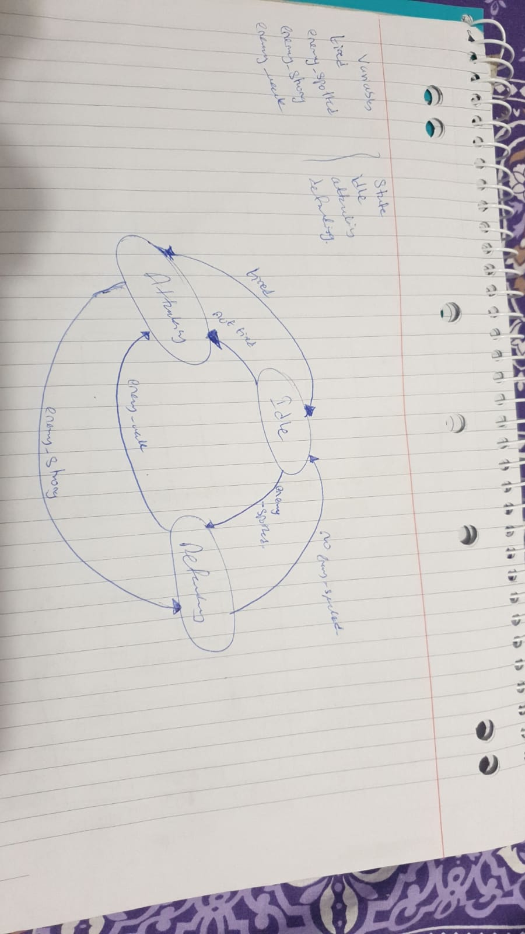  
  
Explanation:

* I have four variables and three states as stated above in the pic.
* The diagram illustrates the transition to each state and forms a cycle
* The initial state is set to idle when the NPC goes on patrol then transitions to attacking or defending state based on the variable values for instance; the NPC checks for nearby enemies and if enemy_spotted value increments to more than 3 it transitions into defending state. On the other hand, if while defending the enemy_spotted drops below 3 it reverts back into ideal state and regains stamina.
* While in attacking state if enemy_strong increments greater than 5 the state is transitioned into defending and the reverts back into attacking if the enemy_weak decrements below 5.

Output:  
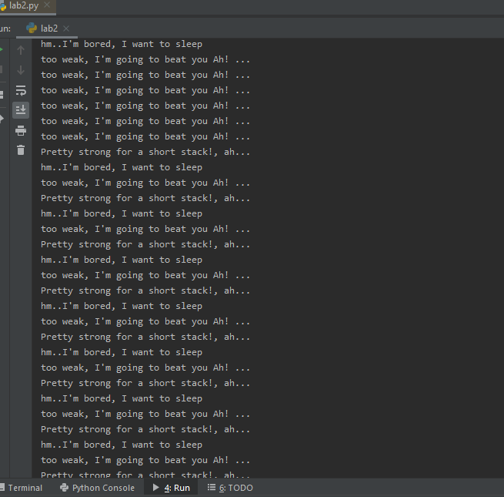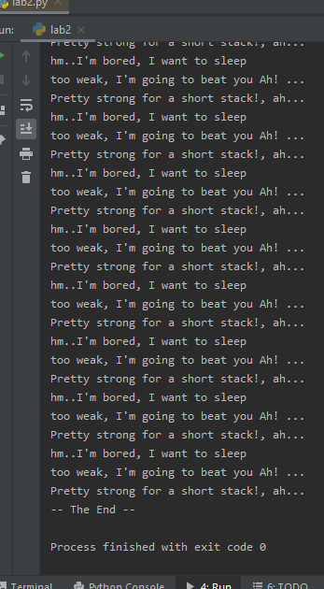

CODE:

# variables  
tired = 0  
enemy_spotted = 0  
enemy_strong = 0  
enemy_weak = 0  
  
  
states = ['idle','attacking','defending',]  
current_state = 'idle'  
  
alive = True  
running = True  
max_limit = 100  
game_time = 0  
  
while running and alive:  
 game_time += 1  
  
 # idle: checks for enemies and tiredness reduces  
 if current_state is 'idle':  
 # Do things for this state  
 print("hm..I'm bored, I want to sleep")  
 tired -= 1  
 enemy_spotted += 1  
 # Check for change state  
 if tired < 5:  
 current_state = 'attacking'  
 if enemy_spotted > 3:  
 current_state = 'defending'  
  
 # attacking: gets tired, has to defend  
 elif current_state is 'attacking':  
 # Do things for this state  
 print("too weak, I'm going to beat you Ah! ...")  
 tired += 1  
 enemy_strong += 1  
 # Check for change state  
 if tired > 5:  
 current_state = 'idle'  
 if enemy_strong > 5:  
 current_state = 'defending'  
   
 # defending: saving stamina. regains strength, kills weak enemy and patrol for more  
 elif current_state is 'defending':  
 # Do things for this state  
 print("Pretty strong for a short stack!, ah...")  
 enemy_spotted -= 1  
 enemy_weak -= 1  
  
 # Check for change state  
 if enemy_weak < 5:  
 current_state = 'attacking'  
 if enemy_spotted < 3:  
 current_state = 'idle